Guía Tecnica programa ROBOMANO USUARIO
DADDY MORENO BELTRAN, WILSON DAVID RAMIREZ OCHOA

10 de junio de 2016
jesus augusto guzman lozan0
Programación orientada a objetos
Tercer Semestre
Universidad Santo Tomás

Contenido

- Introducción.
- Objetivo
- Dirigido a.
- Conocer
- Software asociado
- Pasos a seguir
6.1. Inicio del programa
6.2. Ejecución del programa
- Posibles problemas
- Contacto

INTRODUCCIÓN
Este Proyecto se basa en conocimientos provenientes de áreas como programación y electrónica que al ponerlos en práctica hacen posible la simulación de los movimientos de la mano de un ser humano a través de una mano robótica. Posterior a esto se realizara el análisis, dentro del marco de la física mecánica, del movimiento de caída libre dado por una pelota lanzada desde la mano previamente mencionada.

OBJETIVO
Ayudar e instruir al usuario del programa ROBOMANO a utilizar la interfaz gráfica y poder despejar todas las inquietudes existentes para que pueda comprender:
- Guía para acceder al programa ROBOMANO
- Dominar el sistema, mediante una especificación detallada e ilustrada de las opciones.
- Conocer el alcance de toda la información por medio de una descripción y explicación detallada e ilustrada de cada una de las piezas que la conforman.

¿Para quién va dirigido?
Esta guía técnica esta diseñada para cualquier usuario que desee utilizar el programa de ROBOMANO, incluso si dicho individuo no tiene conocimientos en el área de programación.

¿Qué debes conocer?
Los conocimientos mínimos que deben haber adquirido las personas que poseerán y operarán las siguientes páginas para utilizar este manual son:
- Conocimiento del lenguaje de programación en java.
- Conocimientos básicos interfaz gráfica.

Pasos a seguir
Para una buena ejecución del programa el usuario debe seguir los siguientes pasos:

- El usuario deberá hacer clic en la siguiente opción para abrir el programa

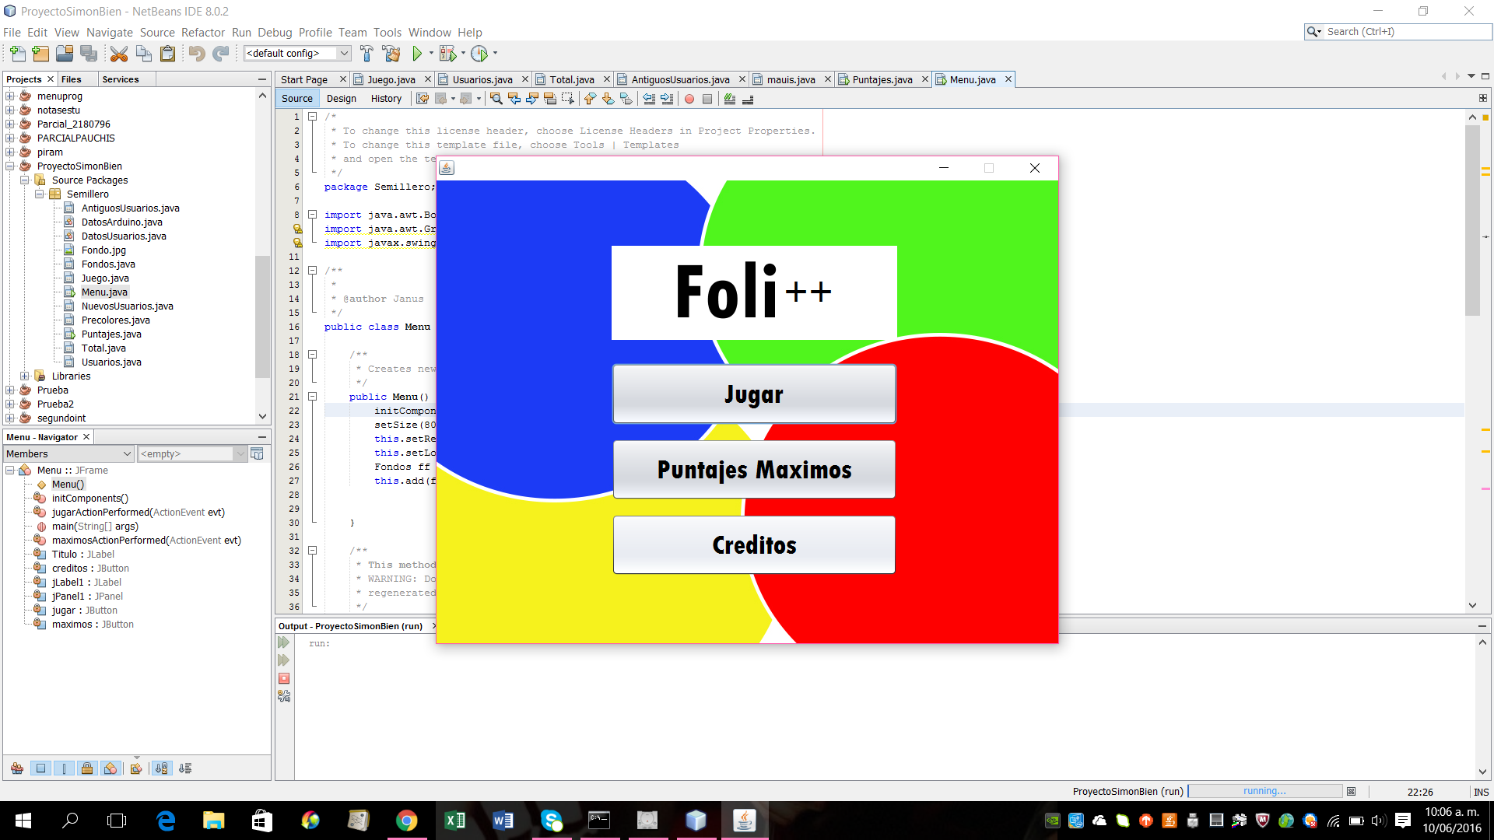

Se abrirá la siguiente ventana

En la ejecución principal se podrá encontrar la siguiente ventana de acceso:

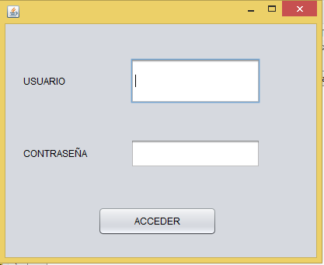

Donde el usuario deberá ingresar su nombre y la respectiva clave de seguridad.
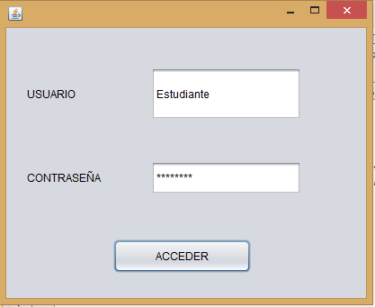

Llegado el caso donde el usuario ingrese errónea mente la clave, nos aparecerá un aviso de alerta como se muestra:

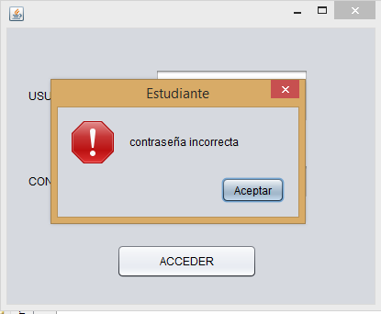
Continuando con la contraseña correcta del usuario el programa nos arrojara automáticamente la siguiente venta donde podremos empezar a manipular las distintas opciones nuestro proyecto, como lo muestra la siguiente imagen:

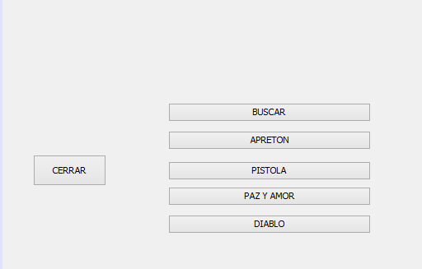

En la presente ventana podremos realizar los distintos tipos de movimientos que deseemos.
A continuación está el programa ROBOMANO EN JAVA.
En la ventana madre 1):
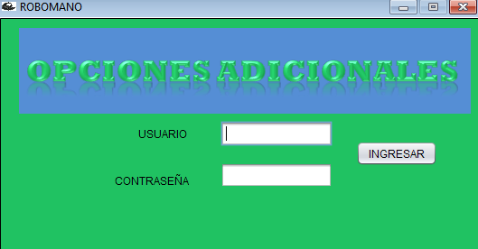
/*
* To change this license header, choose License Headers in Project Properties.
* To change this template file, choose Tools | Templates
* and open the template in the editor.
*/
package GUI;

import java.awt.Dimension;
import java.awt.Toolkit;
import javax.swing.ImageIcon;
import javax.swing.JLabel;
import javax.swing.JLayeredPane;
import javax.swing.JOptionPane;
import javax.swing.JPanel;

/**
*
* @author HIP-HOP
*/
public class contra extends javax.swing.JFrame {

/**
* Creates new form contra
*/
public contra() {
setTitle("ROBOMANO");
Dimension pantalla = Toolkit.getDefaultToolkit().getScreenSize();
int height = pantalla.height;
int width = pantalla.width;
setSize(width / 2, height / 2);

setLocationRelativeTo(null);
setVisible(true);
setIconImage(new ImageIcon(getClass().getResource("/imagen/ii.png")).getImage());
((JPanel) getContentPane()).setOpaque(false);
ImageIcon uno = new ImageIcon(this.getClass().getResource("/imagen/ad.jpg"));
JLabel fondo = new JLabel();
fondo.setIcon(uno);
getLayeredPane().add(fondo, JLayeredPane.FRAME_CONTENT_LAYER);
fondo.setBounds(0, 0, uno.getIconWidth(), uno.getIconHeight());
initComponents();
}

/**
* This method is called from within the constructor to initialize the form.
* WARNING: Do NOT modify this code. The content of this method is always
* regenerated by the Form Editor.
*/
@SuppressWarnings("unchecked")
// <editor-fold defaultstate="collapsed" desc="Generated Code">
private void initComponents() {

jLabel1 = new javax.swing.JLabel();
jLabel2 = new javax.swing.JLabel();
jTextField1 = new javax.swing.JTextField();
jPasswordField1 = new javax.swing.JPasswordField();
jButton1 = new javax.swing.JButton();
jButton2 = new javax.swing.JButton();

setDefaultCloseOperation(javax.swing.WindowConstants.EXIT_ON_CLOSE);
setResizable(false);

jLabel1.setText(" USUARIO");

jLabel2.setText("CONTRASEÑA");

jButton1.setText("VOLVER");
jButton1.addActionListener(new java.awt.event.ActionListener() {
public void actionPerformed(java.awt.event.ActionEvent evt) {
jButton1ActionPerformed(evt);
}
});

jButton2.setText("INGRESAR");
jButton2.addActionListener(new java.awt.event.ActionListener() {
public void actionPerformed(java.awt.event.ActionEvent evt) {
jButton2ActionPerformed(evt);
}
});

javax.swing.GroupLayout layout = new javax.swing.GroupLayout(getContentPane());
getContentPane().setLayout(layout);
layout.setHorizontalGroup(
layout.createParallelGroup(javax.swing.GroupLayout.Alignment.LEADING)
.addGroup(layout.createSequentialGroup()
.addGap(127, 127, 127)
.addGroup(layout.createParallelGroup(javax.swing.GroupLayout.Alignment.TRAILING)
.addComponent(jLabel2)
.addComponent(jLabel1, javax.swing.GroupLayout.PREFERRED_SIZE, 68, javax.swing.GroupLayout.PREFERRED_SIZE))
.addGap(35, 35, 35)
.addGroup(layout.createParallelGroup(javax.swing.GroupLayout.Alignment.LEADING)
.addGroup(layout.createSequentialGroup()
.addGroup(layout.createParallelGroup(javax.swing.GroupLayout.Alignment.TRAILING)
.addGroup(layout.createSequentialGroup()
.addComponent(jTextField1, javax.swing.GroupLayout.PREFERRED_SIZE, 124, javax.swing.GroupLayout.PREFERRED_SIZE)
.addPreferredGap(javax.swing.LayoutStyle.ComponentPlacement.RELATED, 26, Short.MAX_VALUE)
.addComponent(jButton2))
.addComponent(jButton1))
.addGap(46, 46, 46))
.addGroup(layout.createSequentialGroup()
.addComponent(jPasswordField1, javax.swing.GroupLayout.PREFERRED_SIZE, 124, javax.swing.GroupLayout.PREFERRED_SIZE)
.addContainerGap(javax.swing.GroupLayout.DEFAULT_SIZE, Short.MAX_VALUE))))
);
layout.setVerticalGroup(
layout.createParallelGroup(javax.swing.GroupLayout.Alignment.LEADING)
.addGroup(layout.createSequentialGroup()
.addGroup(layout.createParallelGroup(javax.swing.GroupLayout.Alignment.TRAILING)
.addGroup(layout.createParallelGroup(javax.swing.GroupLayout.Alignment.LEADING)
.addGroup(javax.swing.GroupLayout.Alignment.TRAILING, layout.createSequentialGroup()
.addContainerGap()
.addGroup(layout.createParallelGroup(javax.swing.GroupLayout.Alignment.BASELINE)
.addComponent(jLabel1)
.addComponent(jTextField1, javax.swing.GroupLayout.PREFERRED_SIZE, javax.swing.GroupLayout.DEFAULT_SIZE, javax.swing.GroupLayout.PREFERRED_SIZE))
.addGap(18, 18, 18)
.addComponent(jPasswordField1, javax.swing.GroupLayout.PREFERRED_SIZE, javax.swing.GroupLayout.DEFAULT_SIZE, javax.swing.GroupLayout.PREFERRED_SIZE))
.addGroup(layout.createSequentialGroup()
.addGap(137, 137, 137)
.addComponent(jButton2)
.addGap(24, 24, 24)))
.addComponent(jLabel2))
.addPreferredGap(javax.swing.LayoutStyle.ComponentPlacement.RELATED, 68, Short.MAX_VALUE)
.addComponent(jButton1)
.addGap(53, 53, 53))
);

pack();
}// </editor-fold>

private void jButton1ActionPerformed(java.awt.event.ActionEvent evt) {
bien obj = new bien();
obj.setVisible(true);
dispose();
}

private void jButton2ActionPerformed(java.awt.event.ActionEvent evt) {
if (String.valueOf(jTextField1.getText()).compareTo("") == 0 && String.valueOf(jPasswordField1.getPassword()).compareTo("") == 0) {
JOptionPane.showMessageDialog(rootPane, "NO HAY USUARIO NI CONTRASEÑA");
} else if (String.valueOf(jTextField1.getText()).compareTo(jTextField1.getText()) == 0 && String.valueOf(jPasswordField1.getPassword()).compareTo("") == 0) {
JOptionPane.showMessageDialog(rootPane, "NO HAY CONTRASEÑA");
} else if (String.valueOf(jTextField1.getText()).compareTo("") == 0 && String.valueOf(jPasswordField1.getPassword()).compareTo(jPasswordField1.getText()) == 0) {
JOptionPane.showMessageDialog(rootPane, "NO HAY USUARIO");
} else if (String.valueOf(jTextField1.getText()).compareTo("ROBOMANO") == 0 && String.valueOf(jPasswordField1.getPassword()).compareTo("TELECO") == 0) {
codigos obj = new codigos();
JOptionPane.showMessageDialog(rootPane, "UN APRETON DE MANO ES UN GESTO CORDIAL");
obj.setVisible(true);
dispose();
} else {
JOptionPane.showMessageDialog(rootPane, "USUARION O CONTRASEÑA MAL INGRESADOS");
}
}

/**
* @param args the command line arguments
*/
public static void main(String args[]) {
/* Set the Nimbus look and feel */
//<editor-fold defaultstate="collapsed" desc=" Look and feel setting code (optional) ">
/* If Nimbus (introduced in Java SE 6) is not available, stay with the default look and feel.
* For details see http://download.oracle.com/javase/tutorial/uiswing/lookandfeel/plaf.html
*/
try {
for (javax.swing.UIManager.LookAndFeelInfo info : javax.swing.UIManager.getInstalledLookAndFeels()) {
if ("Nimbus".equals(info.getName())) {
javax.swing.UIManager.setLookAndFeel(info.getClassName());
break;
}
}
} catch (ClassNotFoundException ex) {
java.util.logging.Logger.getLogger(contra.class.getName()).log(java.util.logging.Level.SEVERE, null, ex);
} catch (InstantiationException ex) {
java.util.logging.Logger.getLogger(contra.class.getName()).log(java.util.logging.Level.SEVERE, null, ex);
} catch (IllegalAccessException ex) {
java.util.logging.Logger.getLogger(contra.class.getName()).log(java.util.logging.Level.SEVERE, null, ex);
} catch (javax.swing.UnsupportedLookAndFeelException ex) {
java.util.logging.Logger.getLogger(contra.class.getName()).log(java.util.logging.Level.SEVERE, null, ex);
}
//</editor-fold>

/* Create and display the form */
java.awt.EventQueue.invokeLater(new Runnable() {
public void run() {
new contra().setVisible(true);
}
});
}

// Variables declaration - do not modify
private javax.swing.JButton jButton1;
private javax.swing.JButton jButton2;
private javax.swing.JLabel jLabel1;
private javax.swing.JLabel jLabel2;
private javax.swing.JPasswordField jPasswordField1;
private javax.swing.JTextField jTextField1;
// End of variables declaration
}

En la ventana en la cual se utiliza la CONEXIÓN RXTX CON ARDUINO 2):
NOTE: (“para utilizar rxtx en java previamente hay que descargar la librería rxtx y panamahiteck para el debido funcionamiento del programa”)
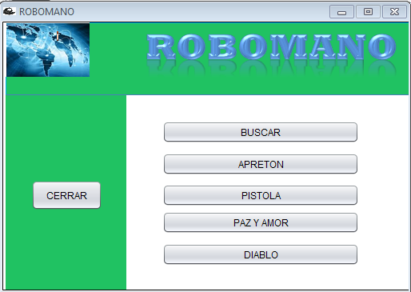

/*
* To change this license header, choose License Headers in Project Properties.
* To change this template file, choose Tools | Templates
* and open the template in the editor.
*/
package GUI;

import com.panamahitek.PanamaHitek_Arduino;
import gnu.io.SerialPortEvent;
import gnu.io.SerialPortEventListener;
import java.awt.Color;
import java.awt.Dimension;
import java.awt.Toolkit;
import java.util.logging.Level;
import java.util.logging.Logger;
import javax.swing.ImageIcon;
import javax.swing.JLabel;
import javax.swing.JLayeredPane;
import javax.swing.JOptionPane;
import javax.swing.JPanel;

/**
*
* @author HIP-HOP
*/
public class codigos extends javax.swing.JFrame {

/**
* Creates new form codigos
*/
int dt2 = 0;
PanamaHitek_Arduino ard = new PanamaHitek_Arduino();
SerialPortEventListener evento = new SerialPortEventListener() {
@Override
public void serialEvent(SerialPortEvent spe) {
dt2 = Integer.parseInt(ard.printMessage());
System.out.println(dt2);

}
};

public codigos() {

getContentPane().setBackground(Color.cyan);
setTitle("ROBOMANO");
Dimension pantalla = Toolkit.getDefaultToolkit().getScreenSize();
int height = pantalla.height;
int width = pantalla.width;
setSize(width / 2, height / 2);

setLocationRelativeTo(null);
setVisible(true);
setIconImage(new ImageIcon(getClass().getResource("/imagen/ii.png")).getImage());
((JPanel) getContentPane()).setOpaque(false);
ImageIcon uno = new ImageIcon(this.getClass().getResource("/imagen/rm.jpg"));
JLabel fondo = new JLabel();
fondo.setIcon(uno);
getLayeredPane().add(fondo, JLayeredPane.FRAME_CONTENT_LAYER);
fondo.setBounds(0, 0, uno.getIconWidth(), uno.getIconHeight());

try {
initComponents();
ard.arduinoRXTX("COM3", 9600, evento);
} catch (Exception ex) {
Logger.getLogger(manojava.class.getName()).log(Level.SEVERE, null, ex);
}
}

/**
* This method is called from within the constructor to initialize the form.
* WARNING: Do NOT modify this code. The content of this method is always
* regenerated by the Form Editor.
*/
@SuppressWarnings("unchecked")
// <editor-fold defaultstate="collapsed" desc="Generated Code">
private void initComponents() {

jButton2 = new javax.swing.JButton();
jButton5 = new javax.swing.JButton();
jButton4 = new javax.swing.JButton();
jButton3 = new javax.swing.JButton();
cerrar = new javax.swing.JButton();
jButton1 = new javax.swing.JButton();

setDefaultCloseOperation(javax.swing.WindowConstants.EXIT_ON_CLOSE);
setResizable(false);

jButton2.setText("CERRAR");
jButton2.addActionListener(new java.awt.event.ActionListener() {
public void actionPerformed(java.awt.event.ActionEvent evt) {
jButton2ActionPerformed(evt);
}
});

jButton5.setText("DIABLO");
jButton5.addActionListener(new java.awt.event.ActionListener() {
public void actionPerformed(java.awt.event.ActionEvent evt) {
jButton5ActionPerformed(evt);
}
});

jButton4.setText("PAZ Y AMOR");
jButton4.addActionListener(new java.awt.event.ActionListener() {
public void actionPerformed(java.awt.event.ActionEvent evt) {
jButton4ActionPerformed(evt);
}
});

jButton3.setText("PISTOLA");
jButton3.addActionListener(new java.awt.event.ActionListener() {
public void actionPerformed(java.awt.event.ActionEvent evt) {
jButton3ActionPerformed(evt);
}
});

cerrar.setText("APRETON");
cerrar.addActionListener(new java.awt.event.ActionListener() {
public void actionPerformed(java.awt.event.ActionEvent evt) {
cerrarActionPerformed(evt);
}
});

jButton1.setText("BUSCAR");
jButton1.addActionListener(new java.awt.event.ActionListener() {
public void actionPerformed(java.awt.event.ActionEvent evt) {
jButton1ActionPerformed(evt);
}
});

javax.swing.GroupLayout layout = new javax.swing.GroupLayout(getContentPane());
getContentPane().setLayout(layout);
layout.setHorizontalGroup(
layout.createParallelGroup(javax.swing.GroupLayout.Alignment.LEADING)
.addGroup(javax.swing.GroupLayout.Alignment.TRAILING, layout.createSequentialGroup()
.addGap(37, 37, 37)
.addComponent(jButton2, javax.swing.GroupLayout.PREFERRED_SIZE, 89, javax.swing.GroupLayout.PREFERRED_SIZE)
.addPreferredGap(javax.swing.LayoutStyle.ComponentPlacement.RELATED, 75, Short.MAX_VALUE)
.addGroup(layout.createParallelGroup(javax.swing.GroupLayout.Alignment.TRAILING, false)
.addComponent(jButton1, javax.swing.GroupLayout.DEFAULT_SIZE, 246, Short.MAX_VALUE)
.addGroup(layout.createParallelGroup(javax.swing.GroupLayout.Alignment.TRAILING, false)
.addComponent(cerrar, javax.swing.GroupLayout.DEFAULT_SIZE, javax.swing.GroupLayout.DEFAULT_SIZE, Short.MAX_VALUE)
.addComponent(jButton3, javax.swing.GroupLayout.DEFAULT_SIZE, javax.swing.GroupLayout.DEFAULT_SIZE, Short.MAX_VALUE)
.addComponent(jButton4, javax.swing.GroupLayout.DEFAULT_SIZE, 246, Short.MAX_VALUE)
.addComponent(jButton5, javax.swing.GroupLayout.DEFAULT_SIZE, javax.swing.GroupLayout.DEFAULT_SIZE, Short.MAX_VALUE)))
.addGap(62, 62, 62))
);
layout.setVerticalGroup(
layout.createParallelGroup(javax.swing.GroupLayout.Alignment.LEADING)
.addGroup(layout.createSequentialGroup()
.addContainerGap(125, Short.MAX_VALUE)
.addComponent(jButton1)
.addPreferredGap(javax.swing.LayoutStyle.ComponentPlacement.UNRELATED)
.addComponent(cerrar)
.addPreferredGap(javax.swing.LayoutStyle.ComponentPlacement.RELATED)
.addGroup(layout.createParallelGroup(javax.swing.GroupLayout.Alignment.BASELINE)
.addComponent(jButton2, javax.swing.GroupLayout.PREFERRED_SIZE, 38, javax.swing.GroupLayout.PREFERRED_SIZE)
.addComponent(jButton3))
.addGap(1, 1, 1)
.addComponent(jButton4)
.addPreferredGap(javax.swing.LayoutStyle.ComponentPlacement.UNRELATED)
.addComponent(jButton5)
.addGap(44, 44, 44))
);

pack();
}// </editor-fold>

private void jButton2ActionPerformed(java.awt.event.ActionEvent evt) {
bien obj = new bien();
obj.setVisible(true);
//dispose();
System.exit(0);
}

private void jButton4ActionPerformed(java.awt.event.ActionEvent evt) {

try {

ard.sendData("8");
JOptionPane.showMessageDialog(this, "BIENVENIDO", "MOVIMIENTO", JOptionPane.OK_OPTION);
} catch (Exception ex) {
Logger.getLogger(manojava.class.getName()).log(Level.SEVERE, null, ex);
}

}

private void jButton5ActionPerformed(java.awt.event.ActionEvent evt) {

try {
ard.sendData("9");
JOptionPane.showMessageDialog(this, "BUENA ENERGIA", "MOVIMIENTO", JOptionPane.OK_OPTION);
} catch (Exception ex) {
Logger.getLogger(codigos.class.getName()).log(Level.SEVERE, null, ex);
}

}

private void jButton3ActionPerformed(java.awt.event.ActionEvent evt) {

try {
ard.sendData("7");
JOptionPane.showMessageDialog(this, "POR NO SALUDARME", "MOVIMIENTO", JOptionPane.OK_OPTION);
} catch (Exception ex) {
Logger.getLogger(codigos.class.getName()).log(Level.SEVERE, null, ex);
}

}

private void cerrarActionPerformed(java.awt.event.ActionEvent evt) {

try {
ard.sendData("0");
JOptionPane.showMessageDialog(this, "HOLA", "MOVIMIENTO", JOptionPane.OK_OPTION);
} catch (Exception ex) {
Logger.getLogger(codigos.class.getName()).log(Level.SEVERE, null, ex);
}

}

private void jButton1ActionPerformed(java.awt.event.ActionEvent evt) {
if (dt2 < 10) {
if (dt2 >0) {
try {
ard.sendData("0");
JOptionPane.showMessageDialog(this, "HOLA", "MOVIMIENTO", JOptionPane.OK_OPTION);
} catch (Exception ex) {
Logger.getLogger(codigos.class.getName()).log(Level.SEVERE, null, ex);
}

}
} else if (dt2 < 25) {
if (dt2 > 10) {
try {

ard.sendData("8");
JOptionPane.showMessageDialog(this, "BIENVENIDO", "MOVIMIENTO", JOptionPane.OK_OPTION);
} catch (Exception ex) {
Logger.getLogger(manojava.class.getName()).log(Level.SEVERE, null, ex);
}
}
} else if (dt2 < 40) {
if (dt2 > 25) {
try {
ard.sendData("7");
JOptionPane.showMessageDialog(this, "POR NO SALUDARME", "MOVIMIENTO", JOptionPane.OK_OPTION);
} catch (Exception ex) {
Logger.getLogger(codigos.class.getName()).log(Level.SEVERE, null, ex);
}

}
} else if (dt2 < 160) {
if (dt2 > 40) {
try {
ard.sendData("9");
JOptionPane.showMessageDialog(this, "BUENA ENERGIA", "MOVIMIENTO", JOptionPane.OK_OPTION);
} catch (Exception ex) {
Logger.getLogger(codigos.class.getName()).log(Level.SEVERE, null, ex);
}
}
}
}

/**
* @param args the command line arguments
*/
public static void main(String args[]) {
/* Set the Nimbus look and feel */
//<editor-fold defaultstate="collapsed" desc=" Look and feel setting code (optional) ">
/* If Nimbus (introduced in Java SE 6) is not available, stay with the default look and feel.
* For details see http://download.oracle.com/javase/tutorial/uiswing/lookandfeel/plaf.html
*/
try {
for (javax.swing.UIManager.LookAndFeelInfo info : javax.swing.UIManager.getInstalledLookAndFeels()) {
if ("Nimbus".equals(info.getName())) {
javax.swing.UIManager.setLookAndFeel(info.getClassName());
break;
}
}
} catch (ClassNotFoundException ex) {
java.util.logging.Logger.getLogger(codigos.class.getName()).log(java.util.logging.Level.SEVERE, null, ex);
} catch (InstantiationException ex) {
java.util.logging.Logger.getLogger(codigos.class.getName()).log(java.util.logging.Level.SEVERE, null, ex);
} catch (IllegalAccessException ex) {
java.util.logging.Logger.getLogger(codigos.class.getName()).log(java.util.logging.Level.SEVERE, null, ex);
} catch (javax.swing.UnsupportedLookAndFeelException ex) {
java.util.logging.Logger.getLogger(codigos.class.getName()).log(java.util.logging.Level.SEVERE, null, ex);
}
//</editor-fold>

/* Create and display the form */
java.awt.EventQueue.invokeLater(new Runnable() {
public void run() {
new codigos().setVisible(true);
}
});
}

// Variables declaration - do not modify
private javax.swing.JButton cerrar;
private javax.swing.JButton jButton1;
private javax.swing.JButton jButton2;
private javax.swing.JButton jButton3;
private javax.swing.JButton jButton4;
private javax.swing.JButton jButton5;
// End of variables declaration
}

Ahora el código de ARDUINO 3)
NOTE(“previamente hay que descargar la librería newping.h para el debido funcionamiento del programa”)
#include <NewPing.h>
#define TRIGGER_PIN 12
#define ECHO_PIN 11
#define MAX_DISTANCE 200
#include <Servo.h> // Incluye la libreria Servo
NewPing sonar(TRIGGER_PIN, ECHO_PIN, MAX_DISTANCE);

Servo me; // Crea el objeto me con las caracteristicas de Servo
Servo an;
Servo co;
Servo in;
Servo pu;
int dato=0;
int dato2;
void setup()
{
Serial.begin(9600);
me.attach(7,600,1500); // Asocia el servo1 al pin 6, define el min y max del ancho del pulso
me.write(180);
an.attach(5,600,1500);
an.write(180);
co.attach(4,600,1500);
co.write(180);
in.attach(3,600,1500);
in.write(0);
pu.attach(2,600,1500);
pu.write(0);
}

void loop()
{
delay(1000);
// Obtener medicion de tiempo de viaje del sonido y guardar en variable uS
int uS = sonar.ping_median();
// Imprimir la distancia medida a la consola serial
//Serial.print("Distancia: ");
// Calcular la distancia con base en una constante
dato2=uS / US_ROUNDTRIP_CM;
Serial.println(dato2);
//Serial.println("cm");

if(Serial.available() >= 0){
dato=Serial.read();
delay(1000);
}

switch(dato){
case '1':
pulgar();
break;
case '2':
indice();
break;
case '3':
corazon();
break;
case '4':
anillo();
break;
case '5':
menique();
break;
case '0':
agarrar();
break;
case '7':
pistola();
break;
case'8':
paz();
break;
case'9':
diablo();
break;
default:
break;

}

}
void menique(){
me.write(0);
delay(2000);
me.write(180);
}
void anillo(){
an.write(0);
delay(2000);
an.write(180);
}
void corazon(){
co.write(0);
delay(2000);
co.write(180);
}
void indice(){
in.write(180);
delay(2000);
in.write(0);
}
void pulgar(){
pu.write(180);
delay(2000);
pu.write(0);
}
void agarrar(){
me.write(0);
an.write(0);
co.write(0);
in.write(180);
pu.write(180);
delay(2000);
me.write(180);
an.write(180);
co.write(180);
in.write(0);
pu.write(0);
}
void diablo(){
an.write(0);
co.write(0);
delay(2000);
an.write(180);
co.write(180);
}
void paz(){
me.write(0);
an.write(0);
pu.write(180);
delay(2000);
me.write(180);
an.write(180);
pu.write(0);
}
void pistola(){
me.write(0);
an.write(0);
in.write(180);
pu.write(180);
delay(3000);
me.write(180);
an.write(180);
in.write(0);
pu.write(0);
}

¿Posibles problemas?
- Llegado el caso que ROBOMANO está en funcionamiento y se desconecte de forma forzosa de un ordenador (PC) se perderá el dominio sobre la máquina.

- Probablemente ROBOMANO no funcione en todos los ordenadores (PC) por motivo de configuración de software del mismo.

- ROBOMANO cuenta con cierta capacidad máxima de funciones.

Contactos

Cualquier duda comunicarse con los siguientes correos se estará atento a sus inquietudes.

- daddymoreno@usantotomas.edu.co
- wilsonramirez@usantotomas.edu.co

